Drill Sheet
Serve Drills
#1 Key:
Spot and move to win

S S S S S S S S

On the wall 8ft up place target. Start servers 5ft from target. Server aims at spot on the wall. If a server hits target they move back one step. They miss they move forward a step. Time for four to five minutes and whoever is the furthest wins.

#2 Key:
Below the line
18 inches Elastic
NET
Place an elastic strip or string from one antenna to another. Have players focus on arm speed to serve low between the string and the net.

#3 Key:
Serve and Pursuit
(Start)1-Server serves to designated area then runs to server 2 position

Coach
Net

2 position server takes a hit from coach then runs to serve line to serve to coach called spot. Player then runs to position to take a hit or tip from coach and then shags ball and returns to serve on opposite side.

Serve line
#4 Key:
Serve to Goal (timed)

Server

4 2 4

2 0 2

4 2 4
Court
Team will split on each side of the net and each player will get a ball.
Team is still earning points as a whole and set a goal together. Coaches
Are on each side of the net scoring the serves. Server will serve and then report
to a coach for score. Timed for five minutes, punishment for not reaching goal.

#5 Key:
Accuracy

1 6 5

2 3 4

Players pair up and go to opposite sides of the courts. One server serves, the other shags teammates serves. Player must serve two balls into each zone without more than two consecutive errors. If two consecutive errors occur, punishment is given. To increase difficulty, ten jumps before serve to increase heart rate.
#6 Key-
Transition 2D

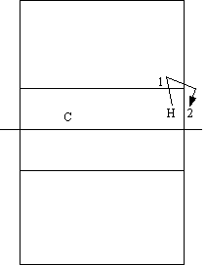 | Objectives:  Use repetition to practice transitioning from defense to offense.  - Hitter starts at the net.  - Coach slaps ball and player transitions to defense.  - Coach hits a ball to the player.  - Coach tosses a ball to the hitter.  - Repeat a set number of times ( 10 or 5 ).  Variations:  - Add blocker(s)  - Close a part of the court to the hitter  ( make hitter hit line or cross).

#7 Key-
“Anything you can do”
Player A calls out a zone for player B. Player B serves to the zone and if successfully hits the zone player A must follow hitting the same zone. If player A misses, player B then gets the chance to call a zone for player A and follow the same procedure. Do jumps to accelerate heart rate to increase difficulty.
If a player misses at any point it is a point for the other player. First to ten loses and has to do a required physical activity.

# 8-use key #6
“Around the world”
Using the same set up, have players start at area one and serve consecutively through the numbers 1,2,3,4,5,6/ At any point the serve is missed, or spot is missed that server is intending to hit, they must start back at one. To increase difficulty, add more serves to each spot before moving on.

#9 Key-
Blocking Numbers
Have your blockers stand in a line (one behind the other)
on one side of the net.
On the other side of the net, set up 5 players on boxes
along the net- each box is assigned a number from 1-5.
Make sure the players on boxes have easy access to
a basket of balls.
To begin, call out a sequence the blocker has to block in
(for example, 5, 1, 4, 2, 3).
The blocker who's up first has to block a ball hit by the
person on box 5, then 1, 4, 2, 3.
If the blockers mess up, they need to start again.
When the blocker gets through the sequence correctly,
the next blocker in line gets a turn (with a new sequence).
Run the drill until each blocker performs 5 different
sequences correctly.
To increase the difficulty, try having 2 blockers go
at a time and perform double blocks.

# 10 Key-
Burn

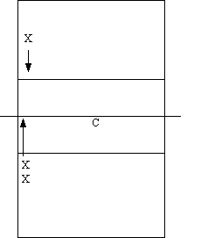 | Objectives:  Practice finding defenders and find an open area to tip to based on where the defender is.  - Coach tosses a ball high outside.  - Outside hitter takes an approach to the net.  - Defender decides whether to charge the tip or stay deep and cover deep tips.  - Next person in the line helps outside hitter by telling them whether the defender is deep or short.  - If the defender is short the outside hitter has to tip over the head of the defender. If the defender is deep then the outside hitter must tip short.  - After the tip outside hitter becomes the defender. Defender gets back in line.  Variations:  Have the outside hitter pass a free or down ball,  and use a setter  Move the defender to left front.

#11 Key-
Reach and Snap Drill

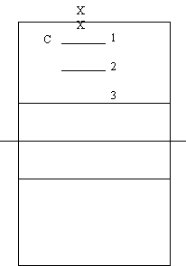 | Objectives:  Teach players to reach high and snap their wrists by tossing the ball off the net the player will have to hit the ball as high as they can and use topspin to keep the ball in the court.  - Split players into groups of three or four.  - Start at number one line.  - Coach tosses balls.  - Players must approach and hit the ball over the net and in the court.  - After a sit number of tosses for each player( 5 ) move up a line.  - Continue until the group is hitting at the net.

#12 Key-
Four Corner Hitting

Objectives:
Practice hitting different shots and tips to different areas on the court.
- Either tape off the corners of the court or place a chair in each corner.
- Coach tosses a ball high outside.
- Outside hitter takes an approach to the net.
- Outside hitter hits or tips to any of the four corners.
- If the hitter hits a chair or corner they get a + 1.
- The outside hitter that has the highest score after a set number of reps wins.
Variations:
Have the outside hitter pass a free or down

#13 Key-
Net Decision

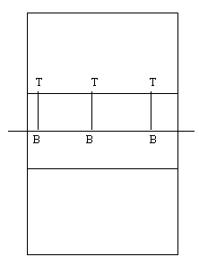  #14 Key- | Objectives:  Teach blockers when to block, hit an overpass, or back off and pass.  - Tossers toss ball over the net to the blocker.  - Blocker must decide whether to block the ball, step off and pass, or to hit the ball.  - Repeat desired number of times.  - Switch tosser and blocker.  Diagram Key:  T = Tosser B = Blocker
Get out of the Hole

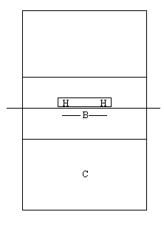 | Objectives:  Teach Blocker aggressiveness and increase blocking stamina.  - Two hitters stand on boxes on the other side of the net.  - Blocker starts in the middle of the net.  - Coach points to a hitter.  - Hitter slaps ball and hits.  - Blocker must get over with feet and penetrate at the net.  - Blocker retreats to middle.  - Repeat for a set number of stuff blocks.  Variations  Move hitters farther apart to increase difficulty.  Diagram Key:  H = Hitter B = Blocker C = Coach
#15 Key-
Overpass Blocking

Objectives:
Teach blockers to watch hitter instead of ball.
- Coach tosses ball from behind blocker over the net to one of the hitters.
- Hitter jumps and hits the ball.
- Blocker jumps, read the hitter's shoulder and tries to stuff the ball.
- If the ball gets past the block the defense tries to dig the ball.
- Repeat by alternating tossers.
Diagram Key:
H = Hitter B = Blocker D = Defender
C = Coach

#16 Key-
Overhead Passing

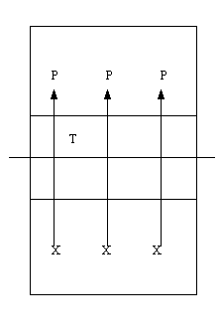 | Objectives:  Practice the transition from serve receive to hitting.  - Starting from left to right the hitters give the passer in line with them down balls.  - Passer must decide whether to forearm pass or over head pass each ball to the target.  - Alternate down the line of hitters.  - Set a goal for number of good passes.  Things to focus on:  Call the ball early, follow the ball out, make the appro  Diagram Key:  X = Hitter X = Passer T = Target
#17 Key-
Emergency Save

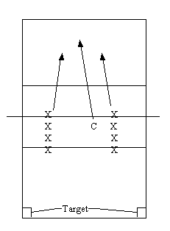 | Objectives:  Practice emergency situations to simulate what to do after a shenked pass.  - Two players stand holding the net.  - Coach tosses a ball deep and high over the net simulating the first touch.  - First player calls the ball and passes the ball high.  - Second player hits a free ball or down ball to the corner.  Diagram Key:  X = Player C = Coach

#18 Key-
Greed

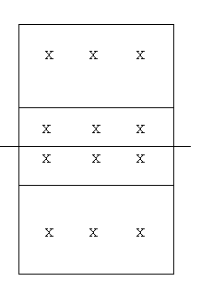 | Objectives:  Practice attitude of wanting to get every point and play.  - Each team starts with 12 balls.  - Each team serves two balls at a time, alternating sides, then rotating.  - The team that wins the rally gets to keep the ball.  - The team that finishes with the most balls wins.  - The team must win by two.  Variations:  Set limitations on the players. For example, no free balls, no down balls, must serve short, must serve deep. etc.

# 19 Key-
Team Control

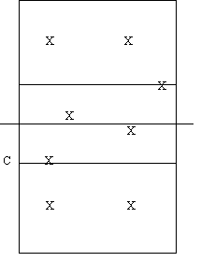 | Objectives:  Practice hitting different shots and tips to different areas on the court  - Coach initiates drill with free or down ball. ( Or toss a ball into the drill and have the first contact pass over the net to the other team ).  - Player passes to the setter.  - Setter sets outside.  - Outside hitter hits a ball to the other team.  - Other team passes, sets and hits back to the team.  Scoring:  The drill is cooperative, meaning the goal of the drill is for both sides of the net to keep the ball in play for as long as possible.
# 20 Key
Ball Control Elimination

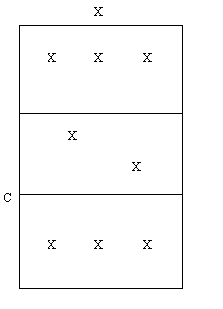 | Objectives:  Practice hitting different shots and tips to different areas on the court  - Coach initiates drill with down or free ball.  - Player passes to the setter.  - Setter sets a back row attack.  - Back row hitter hits to the the team on the other side.  - If the hitter does not hit a ball the other team can get to they are out of the drill.  - Drill continues until there are only two players left ( Setters stay in setting position ), these two play
#21
Front to Back Passing

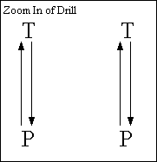 | Objectives:  Practice moving left to right and passing.  - Start the drill with a toss to the passer in the base position shown.  - After passing the passer follows the pass back to the tosser and touches the tosser's foot.  - The passer retreats back to the starting position.  - As the passer retreats the tosser tosses another ball.  - The passer passes the ball and repeats the movements.  - Add the tosser setting while passer transitions.

#22 Key-
Pass and Move

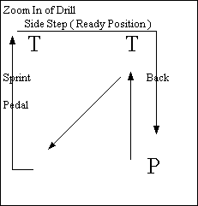 | Objectives:  Practice moving left to right and passing.  - Start the drill with a toss to the passer in the base position shown.  - After the pass the passer sprints up and touches the tosser's foot.  - The passer retreats diagonally back to the next base position, about half way the second tosser tosses the next ball.  - Be sure to have the passer focus on squaring up with the tosser.  - After the second pass the passer sprints to behind the 2nd tosser.  - The passer then shuffles in a ready position behind the tossers.  - After passing to the 1st tosser the passer back pedals back into line.  - Repeat as desired.
#22 Key-
Hit the Pass

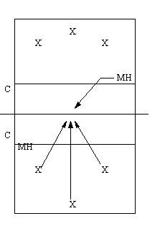 | Objectives:  Practice finding the ball off of a pass, and beat the ball to the setter position.  - Coach gives a free ball to one side to one of the three passers.  - Passers pass the ball up to the net in a whittle position.  - Middle hitters find ball approach and hit ball.  - Give free ball to other side.  - Repeat desired number of times.  Variations: Put setter on the court to give passers a target.  Key:  X = Passers MH = Middle hitters  C = Coach
#23 Key-
Middle Hitter Ball Control

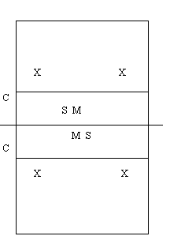 | Objectives:  Practice Transitioning on and off the net quickly, and tip control.  - Coach gives a free ball to one side to one of the two passers.  - Passer passes the ball to the setter.  - Middle hitter starts on the net when the free ball comes.  - Middle hitter starts approach for quick set.  - Setter sets quick middle.  - Middle hitter tips to either wing defender.  - Middle blocker jumps but does not try to block ball.  - Defender passes ball up to the net.  Scoring:  Set a number of contacts (Pass, sets and hits) that the entire group must get in a row.  Middles must get a set number of tips after a set number of free balls, ex. 10 free balls 50 tips.  Key:  X = Passers M = Middle hitters  C = Coach

